OpenCart Application - Project #1

OpenCart is a free, open source e-commerce platform for online merchants. OpenCart provides a professional and reliable foundation from which to build a successful online store. This foundation appeals to a wide variety of users; ranging from seasoned web developers looking for a user-friendly interface to use, to shop owners just launching their business online for the first time. OpenCart has an extensive amount of features that gives you a strong hold over the customization of your store. With OpenCart's tools, you can help your online shop live up to its fullest potential.

| **Requirement** | **Description** | **Priority** | **Acceptance Criteria** |
| --- | --- | --- | --- |
| Login | Users should be able to create an account and log in to the system. | High | 1. User can access the login page from the homepage. 2. User can enter their credentials and click the "login" button. 3. User is redirected to My Account page dashboard upon successful login. 4. User can change password if user forgets the password 5. User can log out |
| Registration | Users should be able to register for a new account. | High | 1. User can access the registration page from the homepage. 2. User can enter their details (name, email, password.) and click the "register" button. 3. User is redirected to My Account page dashboard upon successful registration. |
| Wish List | Users should be able to add products to Wish List | Medium | 1. User can click the "Add to Wish List" button on a product page. 2. The product is added to the user's Wish List. 3. User can view their Wish List and the products they have added. |
| Add to Cart | Users should be able to add products to their cart. | High | 1. User can click the "Add to Cart" button on a product page. 2. The product is added to the user's cart. 3. User can view their cart and the products they have added. |
| Checkout | Users should be able to complete a purchase. | High | 1. User can click the "Checkout" button from their cart page. 2. User can enter their shipping and billing information. 3. User can choose a payment method and complete the transaction. 4. User can use coupon code to reduce price 5. User can use Gift Certificate to reduce price |
| Payment Gateway | The system should integrate with a payment gateway. | High | 1. User can choose from a list of supported payment methods during checkout. 2. User's payment information is securely transmitted to the payment gateway for processing. 3. User receives a confirmation of their payment upon successful processing. |
| Orders | Users should be able to view their order history. | Medium | 1. User can access their order history from their account dashboard. 2. User can view details about their past orders (date, products purchased, total cost, etc.). 3. User can return an order 4. User can view the list of transactions in orders |
| Currency | Users can change their currency for Usability | Medium | 1. User can access currency option in header 2. User can change currency of the whole web application |
| Search | Users can Search for the products | High | 1. Users can Search for an existing product |
| Home Page | Users can view a list of products in Home Page with a few sections | High | 1. Users can see hero images on top of the page 2. Users can see a few products in featured section 3. Users can navigate to brands page by clicking on the listed brands 4. Top menu has categories menu |
| Categories Page | Users can navigate to any categories | Medium | 1. Users can select a category and see relevant products 2. Users can select Subcategory and see relevant products |
| Product Page | Users can view the details of a product | Medium | 1. Users can see thumbnails, price, name, review of the product 2. Users can add and view reviews |
| Product Compare | Users can compare details of the products | Medium | 1. Users can add upto 4 products to compare page 2. Users should be able to view the details of the products side by side |
| My Account | Users can change details of User Account | Medium | 1. Users can be able to edit account information 2. Users can be able to change password 3. Users can add and edit addresses 4. Users can see downloadable orders 5. Users can Subscribe to an order Payment 6. Users can be rewarded with Rewarded points for orders 7. Users can subscribe to newsletter |
| Affiliate | Users can create affiliate account | Medium | 1. Users can add and edit affiliate account 2. Users can generate affiliate link to earn affiliate payment |
| Customer Services | User can access a few user services | Medium | 1. Users can access Contact us page to contact he seller 2. Users can access SiteMap to access a link of various functions |
| Extras | Users can access extra functionalities | Medium | 1. Users can access Specials page for discounted products 2. Users can access Brands page to navigate to brand specific products |
| Header and Footer | User can access Header and Footer options | Medium | 1. Users can access Header and Footer to access various links to pages within app |

### Login

**User Stories**

As a new user, I want to be able to create a new account and login to the platform.

As an existing user, I want to be able to easily access my account by entering my login credentials.

**Design Mockups**

Login page design mockup

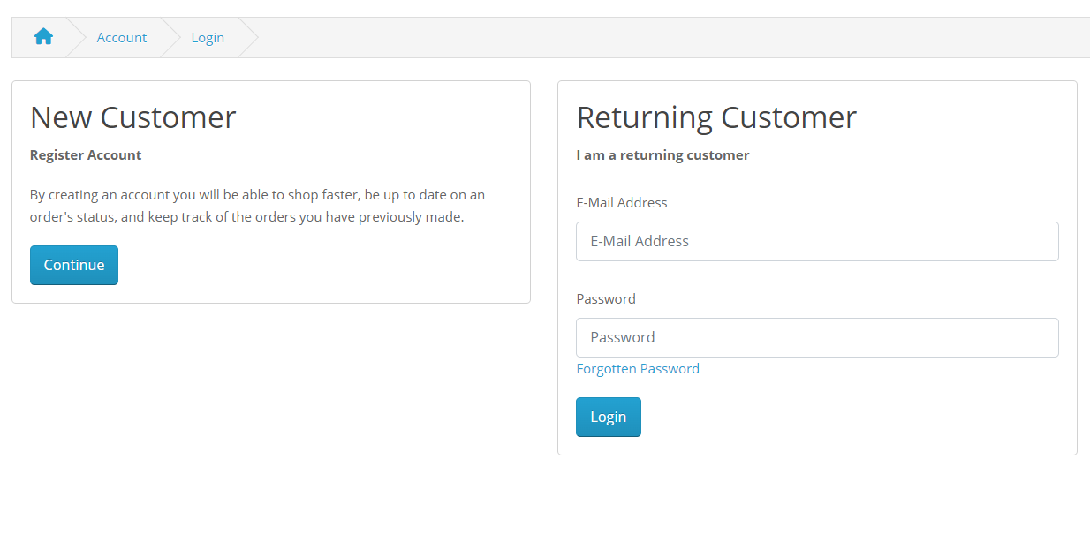

### 

### 

### 

### 

### 

### Registration

**User Stories**

As a new user, I want to be able to easily create a new account and register for the platform.

As an existing user, I want to be able to update my account information and manage my preferences.

**Design Mockups**

Registration page design mockup

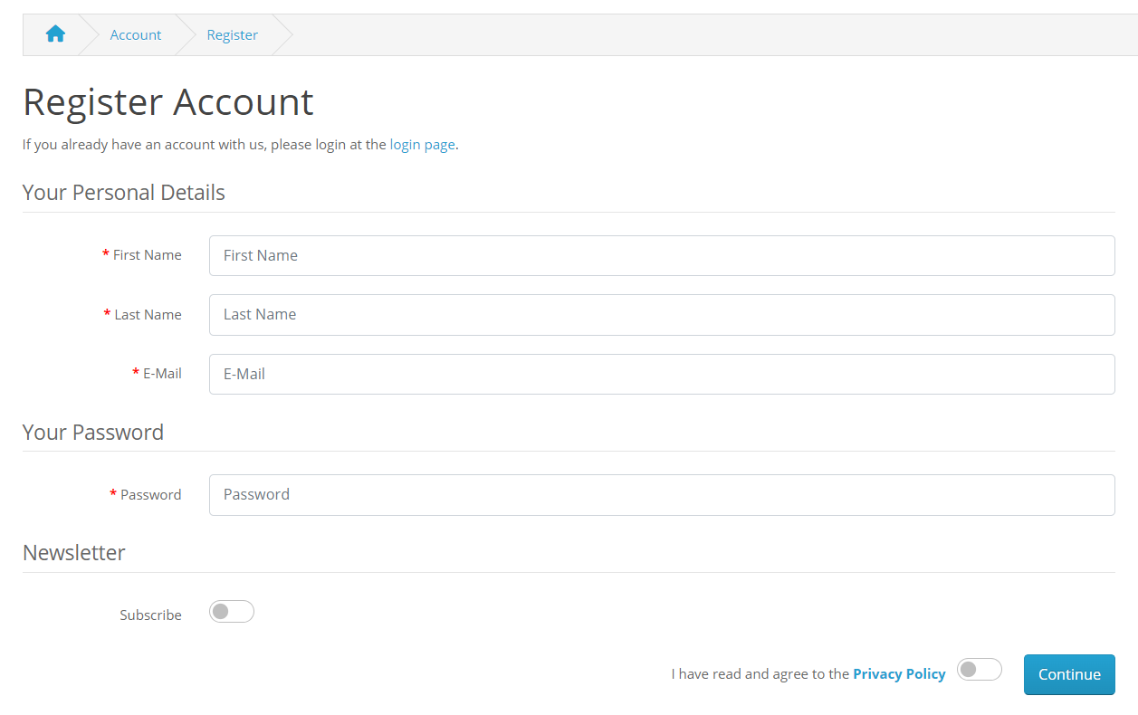

### Wish List

**User Stories**

As a customer, I want to be able to easily add products to Wish List and view my Wish List page.

As a customer, I want to be able to easily manage the contents of my Wish List Page.

**Design Mockups**

WishList page design mockup

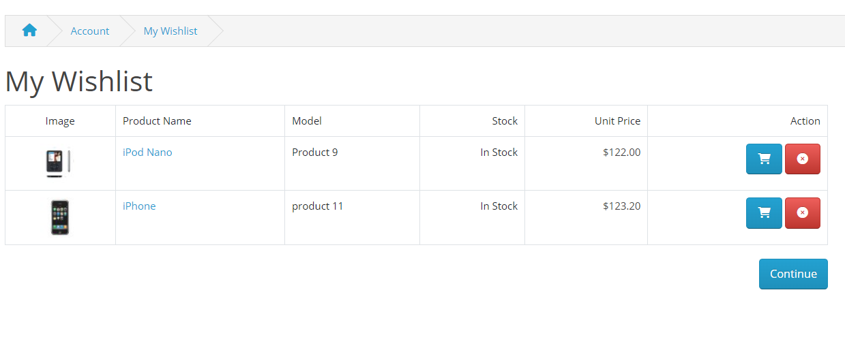

### Add to Cart

**User Stories**

As a customer, I want to be able to easily add products to my cart and view my cart.

As a customer, I want to be able to easily manage the contents of my cart.

**Design Mockups**

Shopping cart design mockup

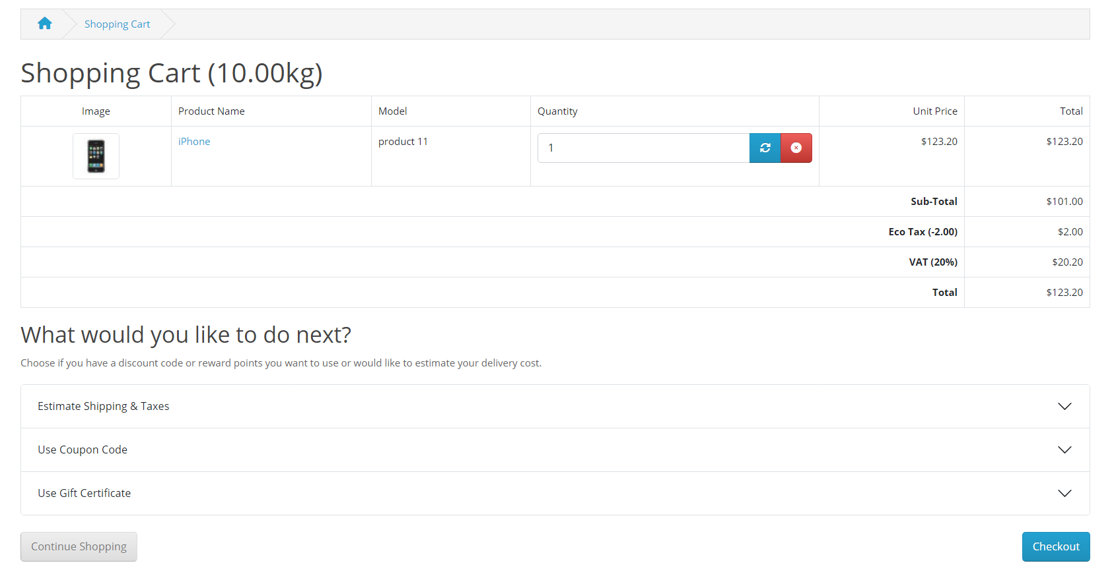

### Checkout

**User Stories**

As a customer, I want to be able to easily complete my purchase and provide my payment information.

As a customer, I want to be able to view my order summary and confirm my purchase.

Verify that users can click the "Checkout" button from their cart page.

Verify that users can enter their shipping and billing information.

Verify that users can choose a payment method and complete the transaction.

Verify that users receive a confirmation of their payment upon successful processing.

**Design Mockups**

Checkout page design mockup

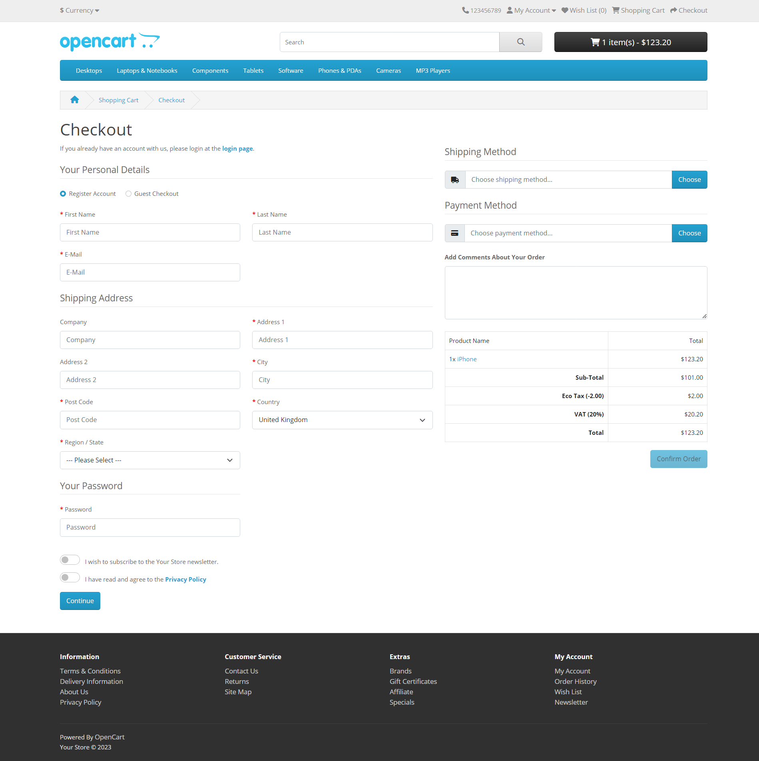

### Payment Gateway

**User Stories**

As a customer, I want to be able to choose from a variety of payment methods and securely enter my payment information.

As a platform, we want to ensure the security of customer payment information and provide a seamless payment experience.

### Orders

**User Stories**

As a customer, I want to be able to view my order history and track the status of my orders.

As a customer, I want to be able to view my order history and track the status of my orders.

**Design Mockup**

Order history page design mockup

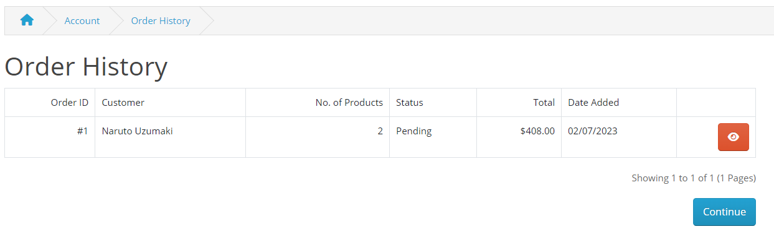

### Currency

**User stories**

As a customer, I want to be able to change currency format to my web app

### Search

**User stories**

As a customer, I want to able to search products from product listings

As a customer, I want to sort the products from search page

**Design Mockup**

Search Page design mockup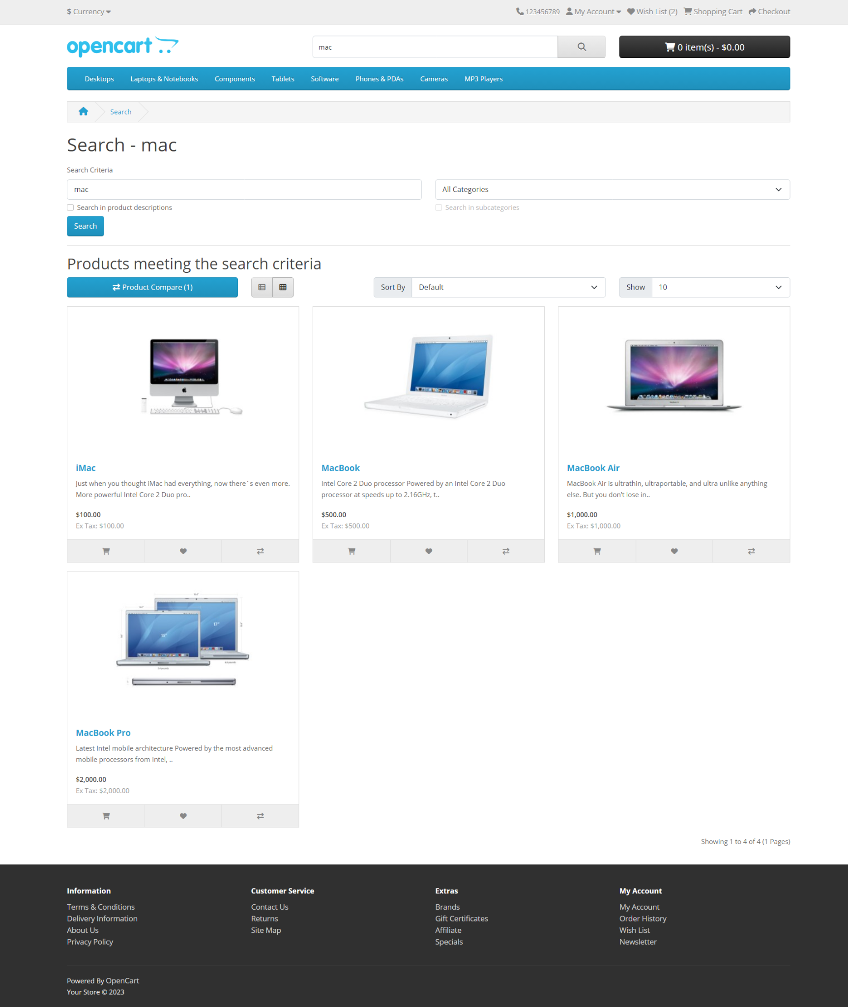

## HomePage

As a user, I want to be able to view hero images in HomePage

As a user, I want to see a few products in features section in HomePage

As a user, I want to view brand list in HomePage

**Design Mockup**

HomePage design mockup

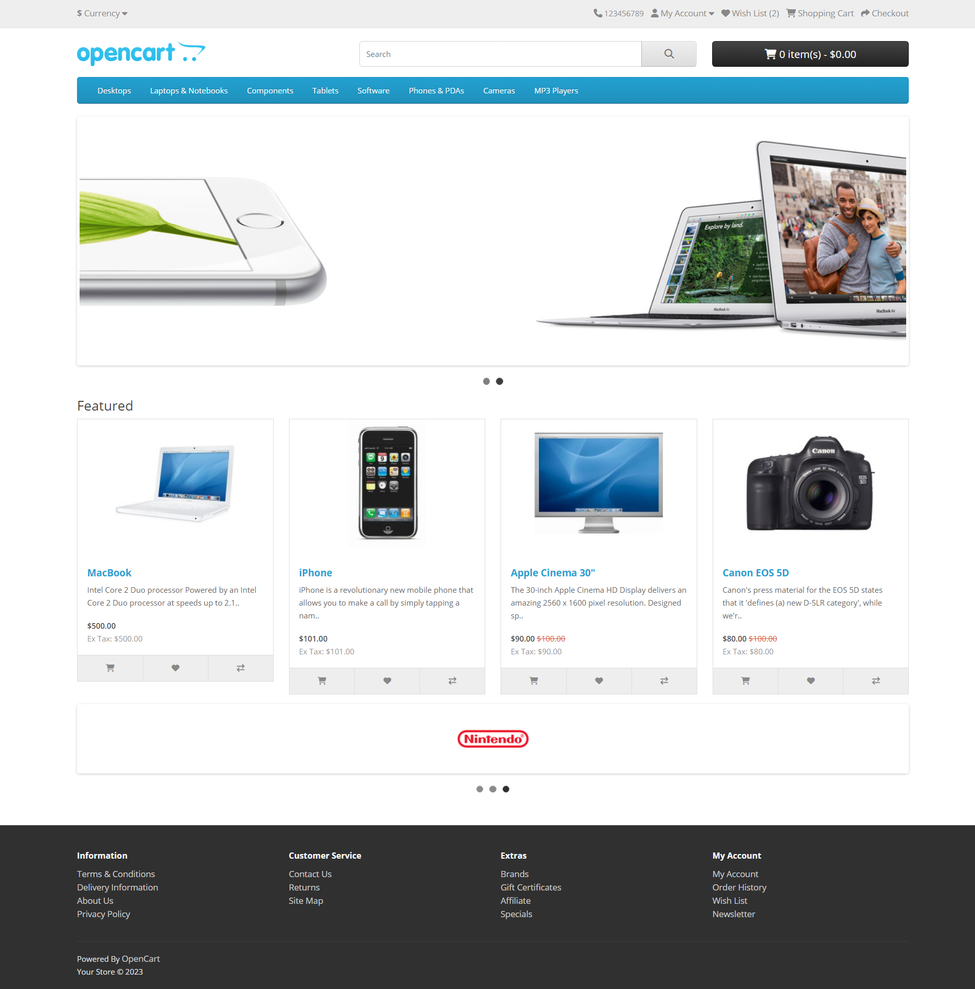

### Categories Page

**User Stories**

As a User, I want to view products by category

As a User I want to view products by subcategory

**Design Mockup**

Category Page design mockup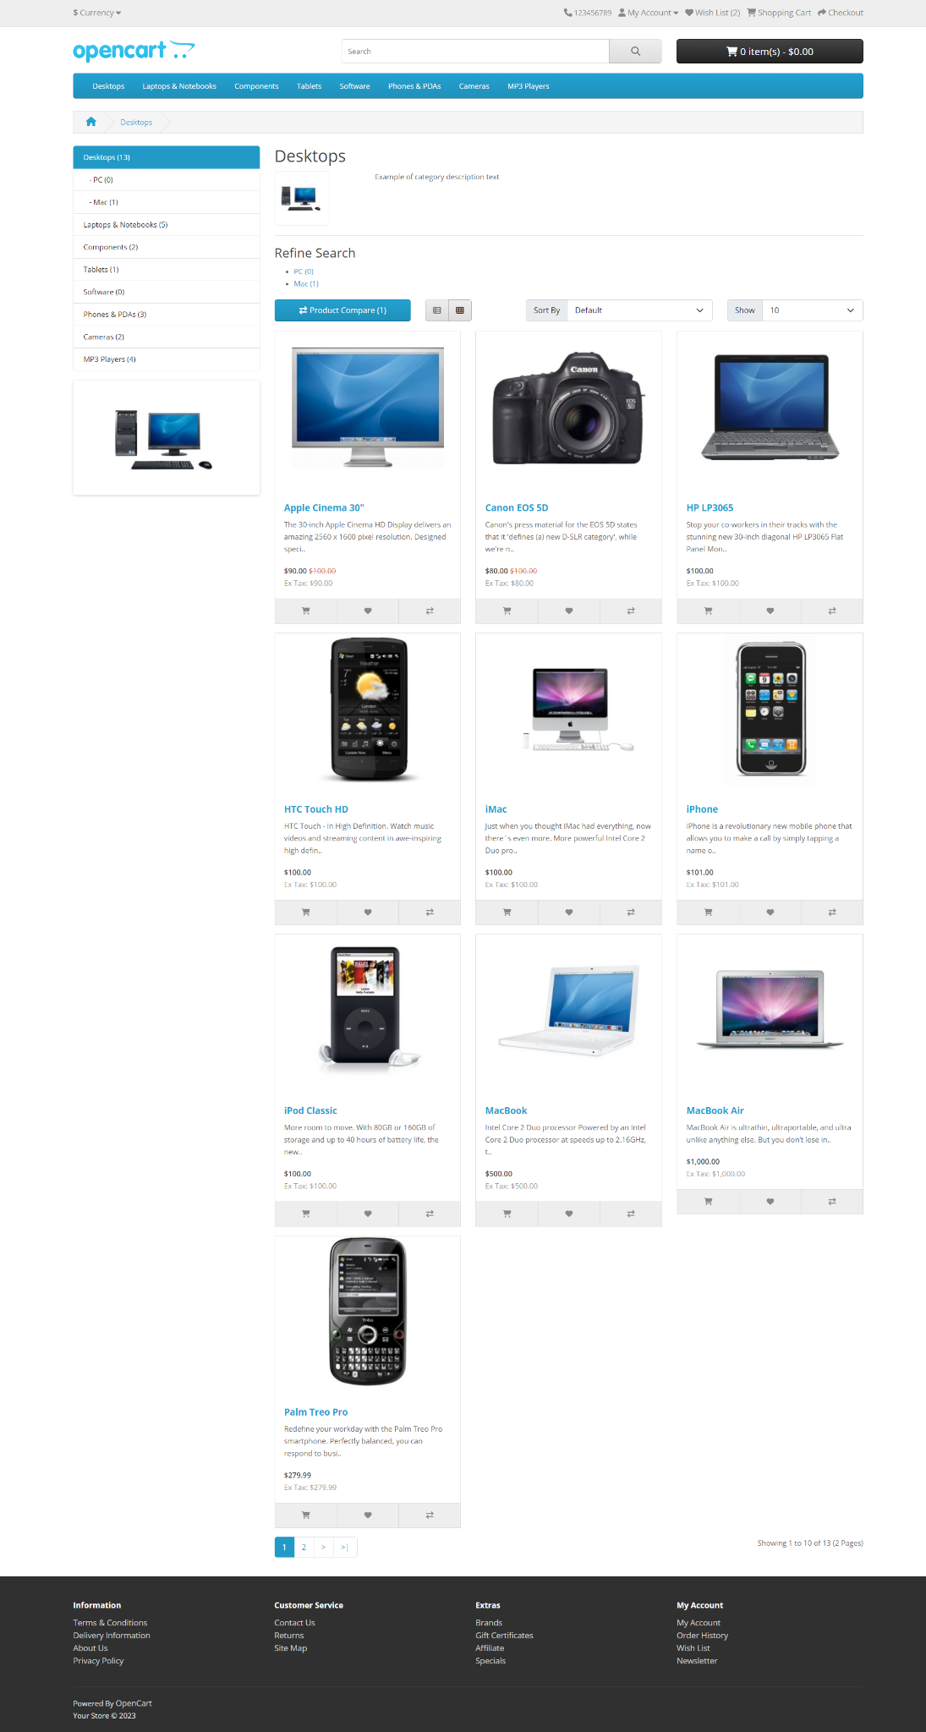

### Product Page

**User stories**

As a user, I want to see the details of the products

As a user, I want to review and view review of the products

**Design Mockup**

Product page design mockup

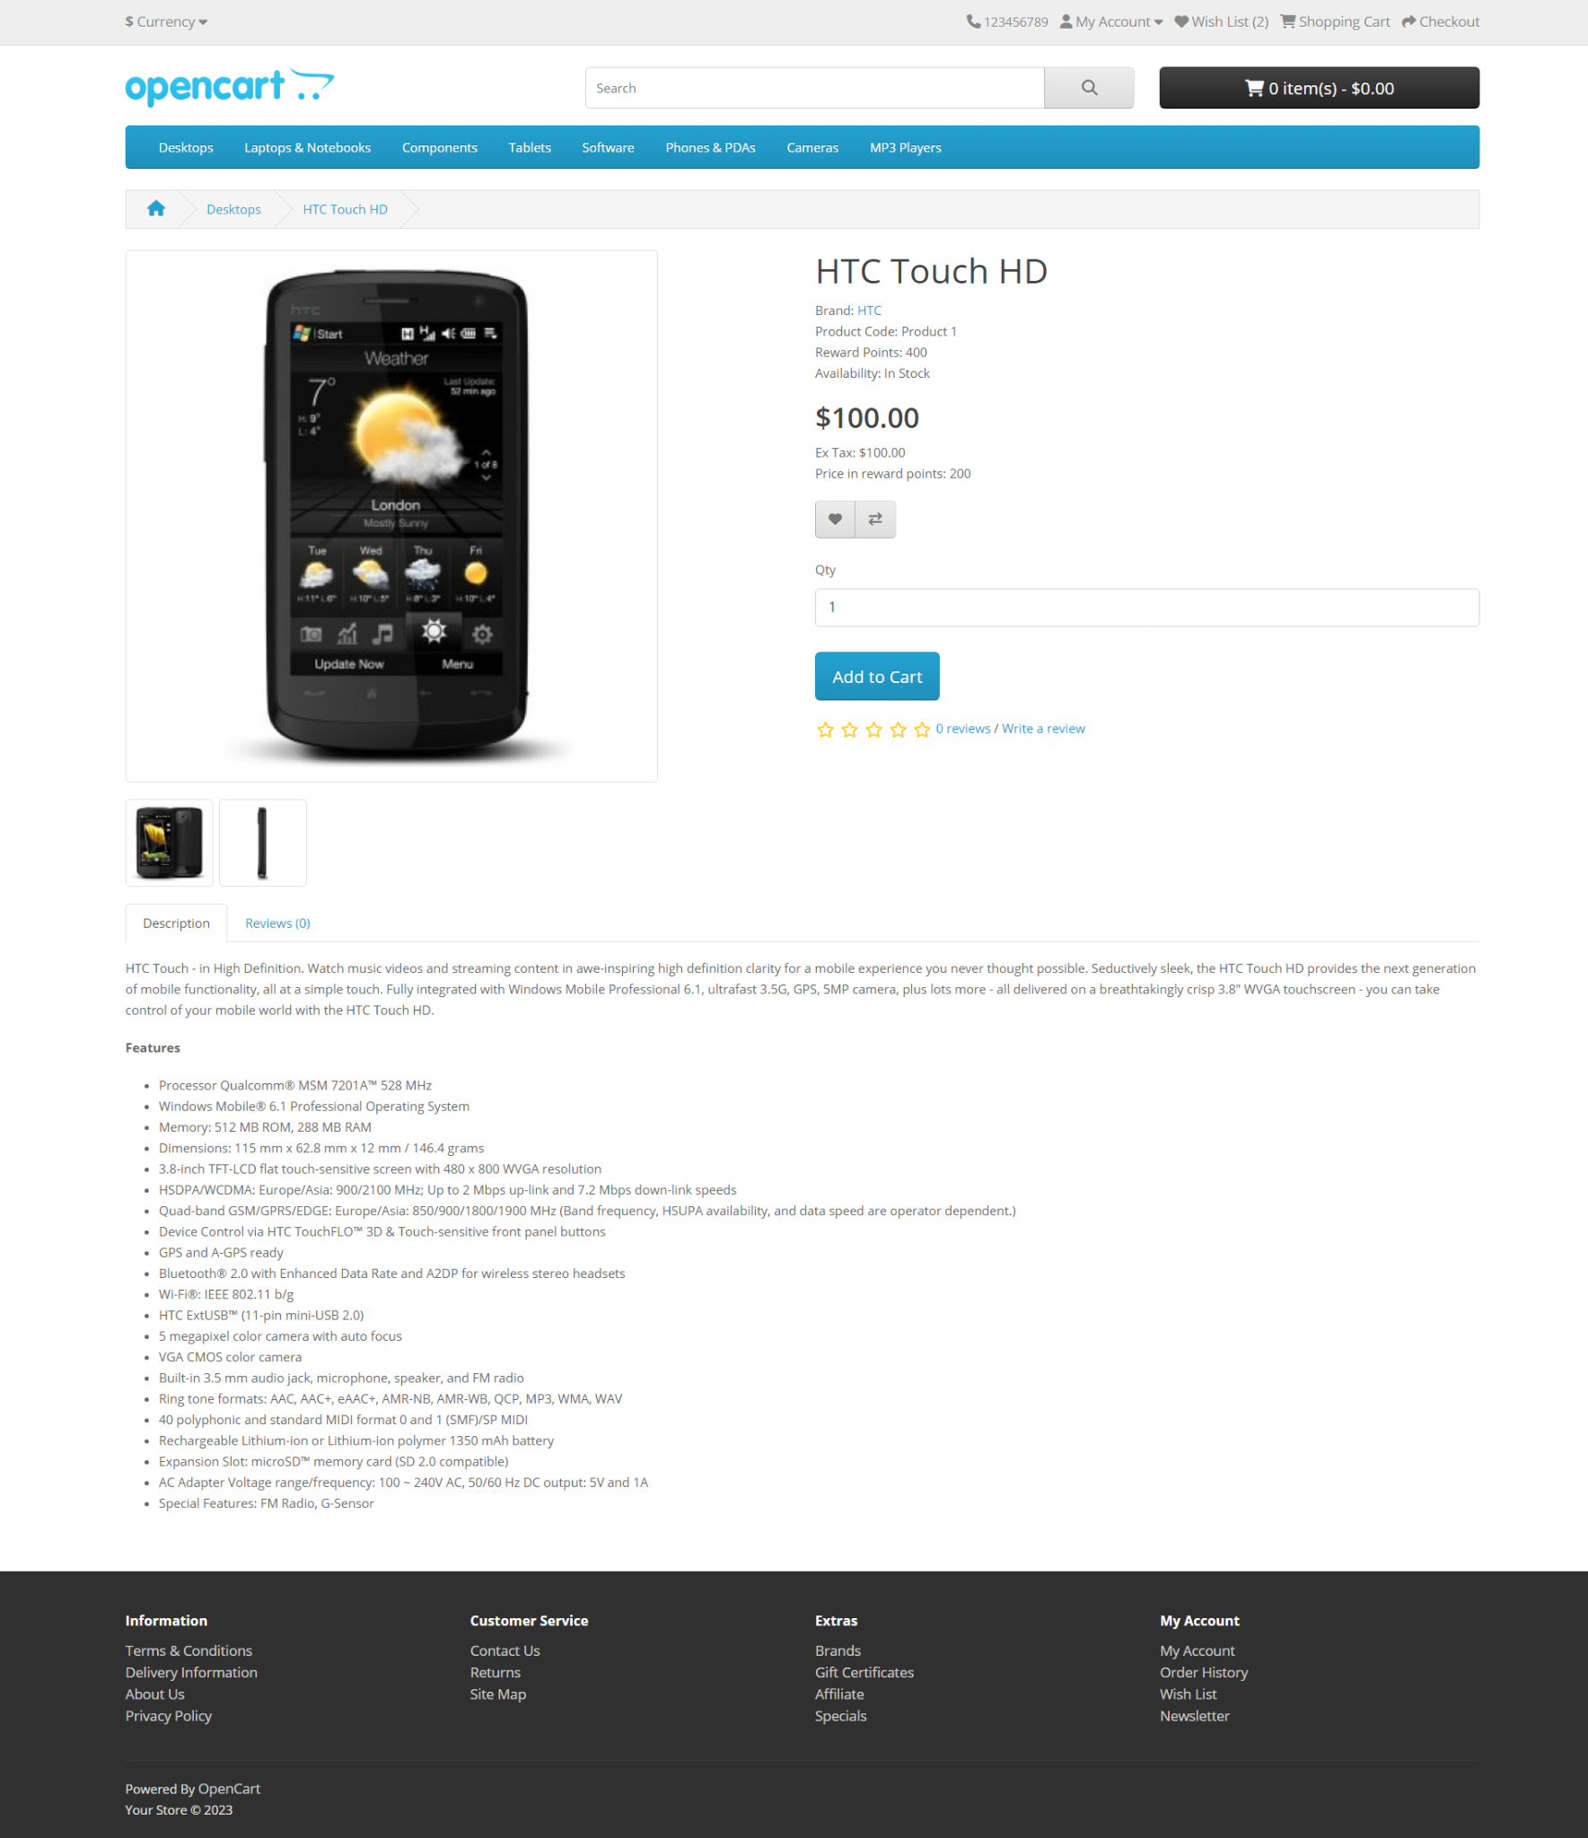

### Product Compare

**User stories**

As a user, I want to compare the details of the products

**Design Mockup**

Product compare page design mockup

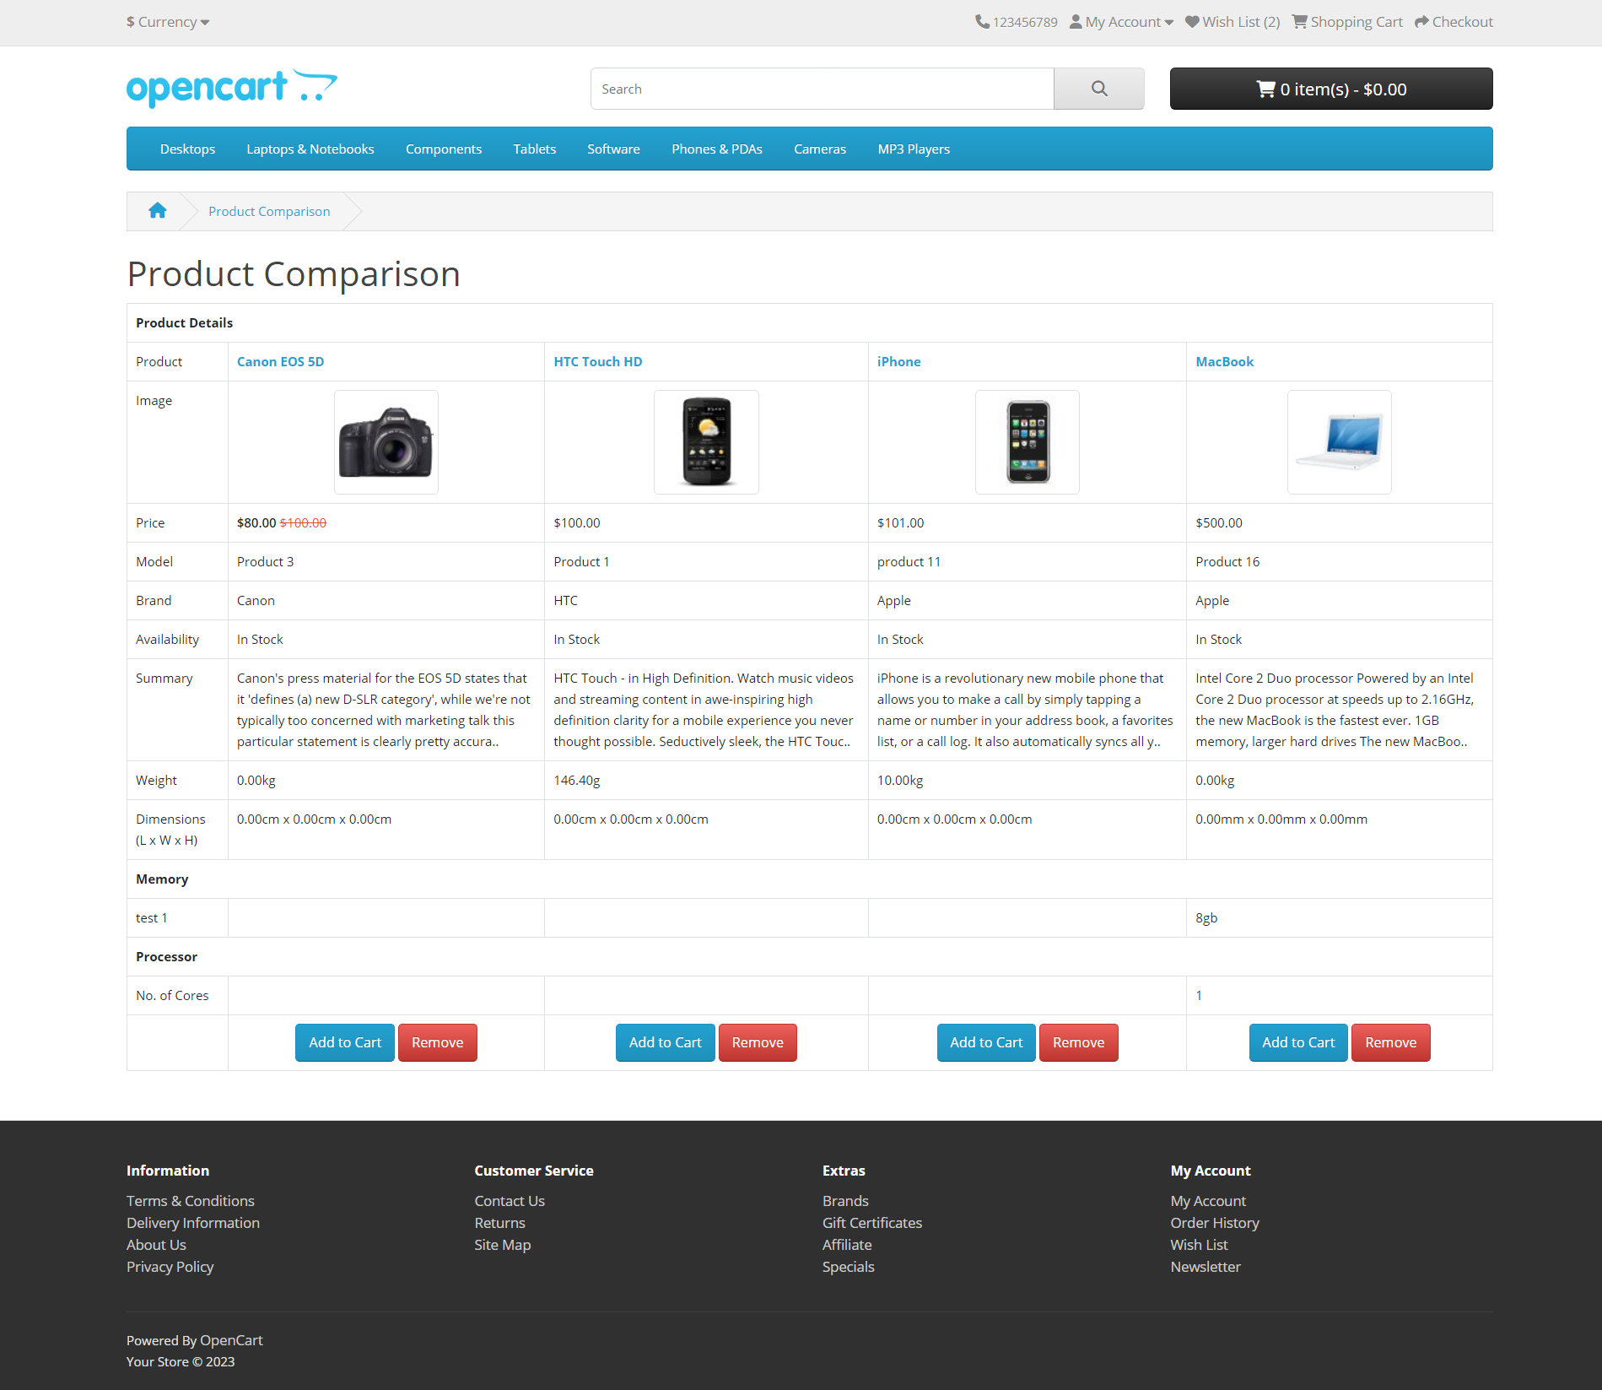

### My Account

**User stories**

As a user, I want to edit the account details

As a user, I want to change password

As a user, I want to add and edit addresses

As a user, I want to get reward points for my orders

As a user, I want to toggle newsletter

**Design Mockup**

My Account page mockup

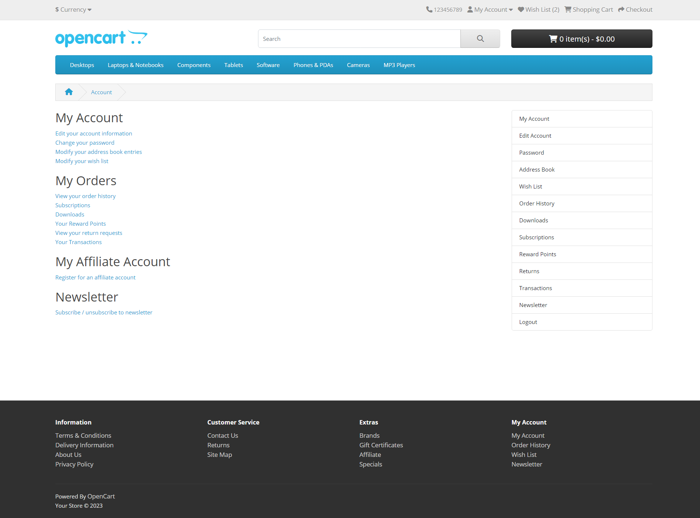

### Affiliate

**User stories**

As a user, I want to register and edit affiliate account

As a user, I want to generate affiliate link to get affiliate payment

### Customer Services

**User stories**

As a user, I want to use contact page to solve issues

As a user, I want to use Sitemap to navigate pages in the Web app

### Extras

**User stories**

As a user, I want to access Specials page to get special offers

As a user, I want to access Brands page

### Header and Footer

**User stories**

As a user, I want to access the options in Header and Footer